Nama : Rima Natalia

Kelas : XII RPL 2

Doc. : Database

**1. Membuat Database**



CREATE DATABASE db_laundry_192010068;

**2. Menambahkan field id_user pada table paket**

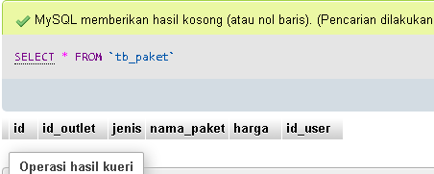

ALTER TABLE tb_paket ADD id_user int;

**3. Menambahkan table tb_absen_kerja dengan field yang sudah ditentukan**

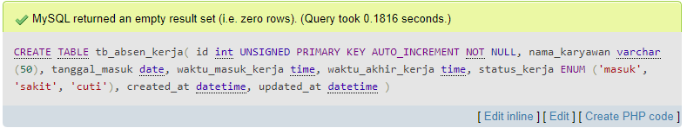

CREATE TABLE tb_absen_kerja(

id int UNSIGNED PRIMARY KEY AUTO_INCREMENT NOT NULL,

nama_karyawan varchar (50),

tanggal_masuk date,

waktu_masuk_kerja time,

waktu_akhir_kerja time,

status_kerja ENUM ('masuk', 'sakit', 'cuti'),

created_at datetime,

updated_at datetime

);

**4. Buat Foreign Key (Indexing) antar table**

ALTER TABLE tb_user ADD CONSTRAINT FOREIGN KEY (id_outlet) REFERENCES tb_outlet(id);

ALTER TABLE tb_paket

ADD CONSTRAINT FOREIGN KEY (id_outlet) REFERENCES tb_outlet(id),

ADD CONSTRAINT FOREIGN KEY (id_user) REFERENCES tb_user(id);

ALTER TABLE tb_transaksi

ADD CONSTRAINT FOREIGN KEY (id_user) REFERENCES tb_user(id),

ADD CONSTRAINT FOREIGN KEY (id_outlet) REFERENCES tb_outlet(id),

ADD CONSTRAINT FOREIGN KEY (id_member) REFERENCES tb_member(id);

ALTER TABLE tb_detail_transaksi ADD CONSTRAINT FOREIGN KEY (id_transaksi) REFERENCES tb_transaksi(id);

**5. Menambahkan 10 data pada table tb_absen_kerja**

INSERT INTO tb_absen_kerja

(nama_karyawan, tanggal_masuk, waktu_masuk_kerja, waktu_akhir_kerja, status_kerja, created_at, updated_at)

VALUES

("Isti", "2022-03-22", "07:00", "16:00", "sakit", NOW(), NOW()),

("Ara", "2022-03-25", "07:00", "16:00", "masuk", NOW(), NOW()),

("Jae", "2022-03-23", "07:00", "16:00", "cuti", NOW(), NOW()),

("Jeno", "2022-03-22", "07:00", "16:00", "sakit", NOW(), NOW()),

("Sisi", "2022-03-25", "07:00", "16:00", "masuk", NOW(), NOW()),

("Tiway", "2022-03-28", "07:00", "16:00", "cuti", NOW(), NOW()),

("Amanda", "2022-03-27", "07:00", "16:00", "sakit", NOW(), NOW()),

("Doyi", "2022-03-26", "07:00", "16:00", "masuk", NOW(), NOW()),

("Chi", "2022-03-30", "07:00", "16:00", "sakit", NOW(), NOW()),

("Azyn", "2022-03-29", "07:00", "16:00", "cuti", NOW(), NOW());

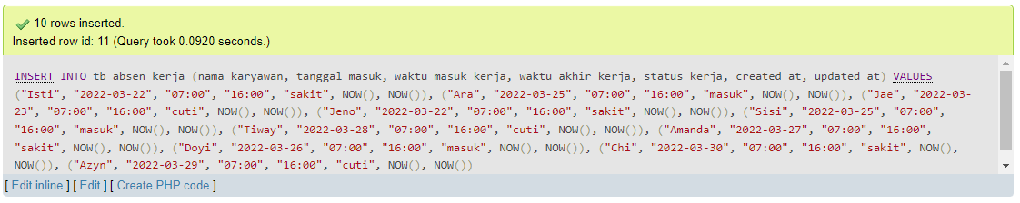

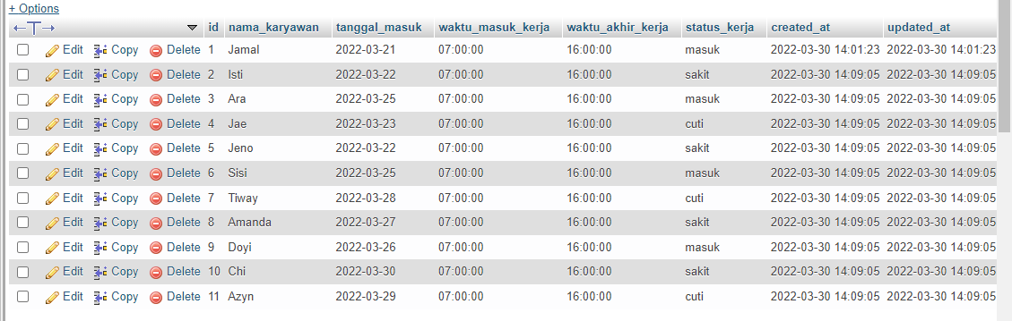

**6. Membuat instruksi SQL untuk menampilkan data di tb_absen_kerja yang statusnya “sakit”**

SELECT * FROM tb_absen_kerja WHERE tanggal_masuk = "2022-03-22" AND status_kerja ="sakit";

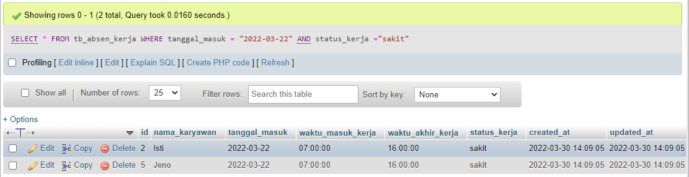

**7. Buat satu intruksi SQL untuk mengupdate data di tb_absen_kerja dengan nama kalian yang tanggal_masuk antara 21-03-2022 sampai 23-03-2022**

UPDATE tb_absen_kerja SET nama_karyawan = "RIMA NATALIA" WHERE (tanggal_masuk BETWEEN '2022-03-21' AND '2022-03-23');

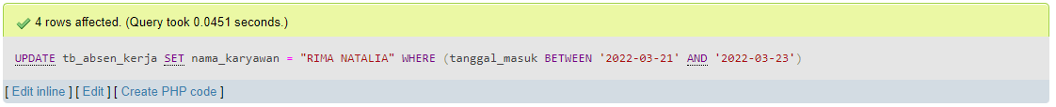

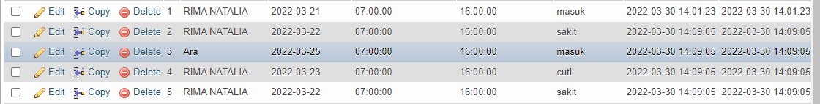

**8. Membuat Stored Procedure yang memiliki status selesai dan jenis paket kaos**

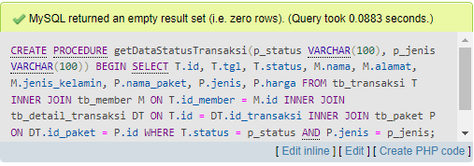

//

CREATE PROCEDURE getDataStatusTransaksi(p_status VARCHAR(100), p_jenis VARCHAR(100))

BEGIN

SELECT T.id, T.tgl, T.status, M.nama, M.alamat, M.jenis_kelamin, P.nama_paket, P.jenis, P.harga

FROM tb_transaksi T

INNER JOIN tb_member M ON T.id_member = M.id

INNER JOIN tb_detail_transaksi DT ON T.id = DT.id_transaksi

INNER JOIN tb_paket P ON DT.id_paket = P.id

WHERE T.status = p_status

AND P.jenis = p_jenis;

END

//

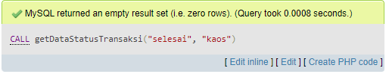

CALL getDataStatusTransaksi("selesai", "kaos");

**9. Buat Function Menghasilkan Total_Uang_bayar**

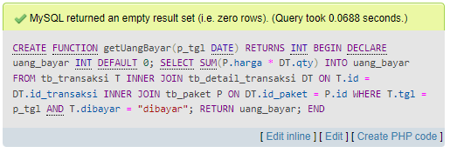

//

CREATE FUNCTION getUangBayar(p_tgl DATE) RETURNS INT

BEGIN

DECLARE uang_bayar INT DEFAULT 0;

SELECT SUM(P.harga * DT.qty) INTO uang_bayar FROM tb_transaksi T

INNER JOIN tb_detail_transaksi DT ON T.id = DT.id_transaksi

INNER JOIN tb_paket P ON DT.id_paket = P.id

WHERE T.tgl = p_tgl AND T.dibayar = "dibayar";

RETURN uang_bayar;

END

//

**10. Membuat table logging dan 3 trigger pada table tb_absen_kerja**

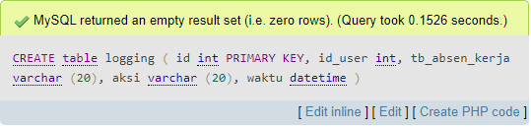

CREATE table logging (

id int PRIMARY KEY,

id_user int,

tb_absen_kerja varchar (20),

aksi varchar (20),

waktu datetime

);

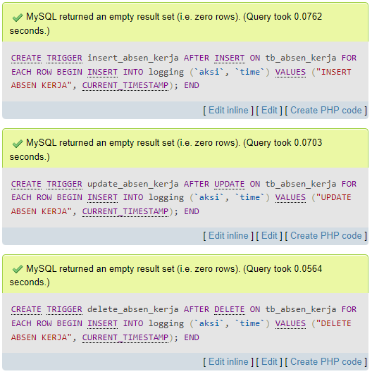

CREATE TRIGGER insert_absen_kerja AFTER INSERT ON tb_absen_kerja FOR EACH ROW

BEGIN

INSERT INTO logging (`aksi`, `time`) VALUES ("INSERT ABSEN KERJA", CURRENT_TIMESTAMP);

END//

CREATE TRIGGER update_absen_kerja AFTER UPDATE ON tb_absen_kerja FOR EACH ROW

BEGIN

INSERT INTO logging (`aksi`, `time`) VALUES ("UPDATE ABSEN KERJA", CURRENT_TIMESTAMP);

END//

CREATE TRIGGER delete_absen_kerja AFTER DELETE ON tb_absen_kerja FOR EACH ROW

BEGIN

INSERT INTO logging (`aksi`, `time`) VALUES ("DELETE ABSEN KERJA", CURRENT_TIMESTAMP);

END//

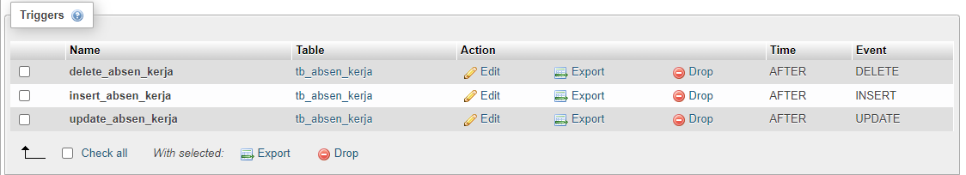

**11. Membuat v_transaksi_selesai**

CREATE VIEW v_transaksi_selesai AS

SELECT T.id, T.tgl, T.status, M.nama, M.alamat, M.jenis_kelamin, SUM(P.harga * DT.qty) AS total_bayar

FROM tb_transaksi T

INNER JOIN tb_member M ON T.id_member = M.id

INNER JOIN tb_detail_transaksi DT ON T.id = DT.id_transaksi

INNER JOIN tb_paket P ON DT.id_paket = P.id

WHERE T.status = "selesai"

GROUP BY T.id;

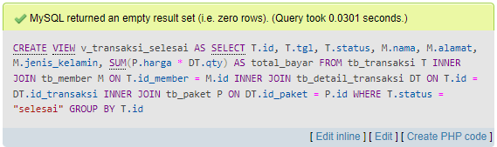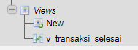

**12. Perintah COMMIT**

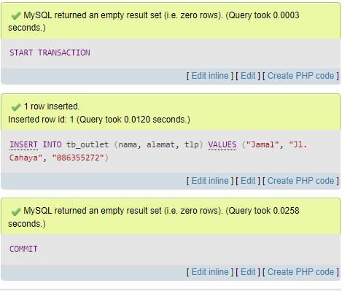

START TRANSACTION;

INSERT INTO tb_outlet (nama, alamat, tlp)

VALUES ("Jamal", "Jl. Cahaya", "086355272");

COMMIT;

**13. Perintah ROLLBACK**

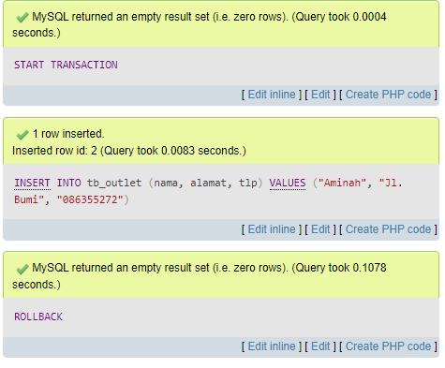

START TRANSACTION;

INSERT INTO tb_outlet (nama, alamat, tlp)

VALUES ("Aminah", "Jl. Bumi", "086355272");

ROLLBACK;

**14. BACKUP & RESTORE**



